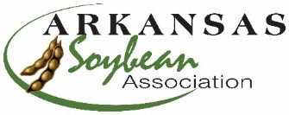

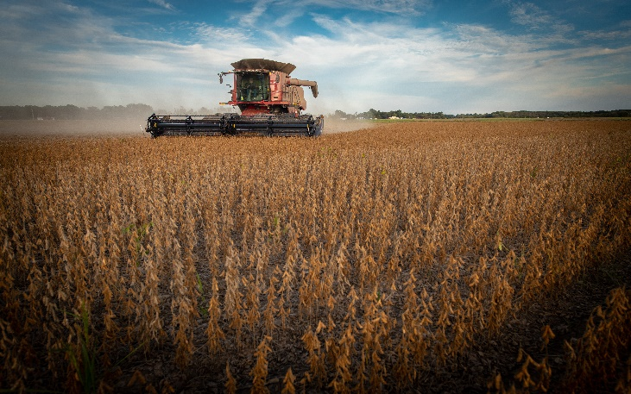
Soybean Yield Contest Winners Announced

The Arkansas Soybean Promotion Board and the Arkansas Soybean Association are pleased to announce the winners of the 2022 Grow for the Green Soybean Yield Contest. Find additional hi-res photos of the winners, here.

BRINKLEY, Ark. (January 25, 2023) - The Arkansas Soybean Promotion Board (ASPB) and the Arkansas Soybean Association (ASA) are pleased to announce the 2022 Grow for the Green Soybean Yield Contest winners. The contest divides state soybean producers into nine groups, seven geographic regions, one all-state conventional (non-GMO) category and a Champions Category consisting of all previous 100-bushel winners. Cash prizes were awarded to the top three in each division achieving a minimum of 60 bushels/acre with the exception of the Champions. Winners were announced at the Arkansas Soybean Association Annual Meeting.

“I continue to be genuinely impressed by the incredibly high-achieving performance that our soybean producers manage to accomplish year after year. This year is no exception,” said Derek Helms, a farmer from Clark County and ASA president. “This contest not only helps our mission to improve the agronomic practices of producers in Arkansas, it also serves as a platform to showcase the innovation and industry leadership consistently demonstrated by our producers across the state.”

ASA commends all 71 soybean producers who entered the 2022 Grow for the Green Soybean Yield Contest, particularly the three producers who reached and exceeded the 100 bushel/acre milestone in 2022. The Race for 100 Yield Contest began in 2007 and, in 2013, the first three producers reached the goal.

“The Arkansas soybean industry has come a long way since the crop was first introduced to local farmers in 1926. A lot of improvement in the industry has occurred in those 97 years, but that improvement has arguably intensified since 2007 when this contest was established,” said Doug Hartz, a soybean farmer from Arkansas County and ASPB vice chairman. “We’re proud to continue our support of this contest and its goal of helping producers maintain soybean’s position as the state’s top row crop.”

Matt Miles from Desha County achieved the 100-bushel mark for the eighth time with a yield of 122.884 bushel/acre by growing Asgrow 46X0 and winning the Champion Division.

Following are the winners of the 2022 Grow for the Green Soybean Yield Contest. Production methods and management practices are available for review here.

Division Producer County Variety Final Yield (bu/ac)
1-Northeast Delta Roger Reddick Greene Pioneer P48A60X 99.480
Jeff Wells Greene AgriGold 4620 88.127
Allen Griffin Greene Asgrow 47XFO 79.661
Casey Hook Craighead AgriGold 4620 RX 73.421

2-Northeast Zack Brown Clay Pioneer P47A64AX 90.665
Karl Garner Cross Pioneer P45A40LX 83.963
Judd Cunningham Poinsett Becks 4885 76.289

3-White River Basin Richard Walker Jackson Pioneer P49A41L 88.011
Greg King/John Walker/ Jackson Pioneer P49A41L 84.482
Rob Walker
Jerry Fuller Monroe Pioneer P46A20LX 74.053

4-Central/Grand Prairie Taylor Burdett Arkansas Pioneer P44A21X 99.752
David Strohl Prairie Dyna-Gro S45es10 89.927

5-East Central Delta Blake Culp Phillips Asgrow 48X9 97.081
Leonard Rohrscheib Phillips Asgrow 48XF0 93.843
Leonard Rohrscheib Jr. Phillips Asgrow 48XF0 91.759
Parker Rohrscheib Phillips Asgrow 48XF0 83.374

6-Southeast Delta No entries in this division.

7 - Western Blake Mans Yell Pioneer P48A14e 82.440
Ronnie Cross Yell Pioneer P44A91 73.846
James Gregory Conway Pioneer P47T39 65.033

Conventional Riley Stephens Cross Virtue 4520 84.519
Jake Hunter Stephens Cross Virtue 4520 84.298
John R. Stephens Cross Virtue 4520 82.312
Retha Stephens Cross Virtue 4520 72.784
Dennis Stephens Cross Virtue 4520 66.705

Champions Group Matt Miles Ashley Asgrow 46X0 122.884
Layne Miles Ashley Asgrow 46X0 122.301
Sherrie Miles Ashley Agrigold 4620X 109.572
Neil Culp Phillips Asgrow 48X9 95.322
Blake & Kent Bennett Randolph Pioneer P49A41 90.327
Linwood Wells Greene Pioneer P48A60 82.919
Tim Fisher Cross Pioneer P45A40LX 78.549
Brandon Cain White Asgrow 48X9 73.489
Ronnie Ragsdell Lawrence DynaGro 46XF31 66.947

The Grow for the Green Yield Soybean Yield Challenge is funded by the Arkansas Soybean Promotion Board and administered by the Arkansas Soybean Association in cooperation with the University of Arkansas System Division of Agriculture. Technical support is provided by county extension staff and independent consultants who help producers achieve these yields and serve as harvest judges.

For complete harvest results from the year’s contest, click here or visit www.arkansassoybean.com and www.themiraclebean.com.

###

The Arkansas Soybean Promotion Board is led by nine volunteer farmer-leaders nominated by various producer organizations in Arkansas and appointed by the Governor. Soybeans are Arkansas's top row crop with approximately 3 million acres planted each year, generating an annual economic impact of $2 billion. Arkansas is consistently ranked among the top ten soybean producing states nationally, exporting 50% of its crop. ASPB invests more than $2.2 million in research each year as part of its commitment to the continued sustainability of the Arkansas soybean industry. Learn more by visiting TheMiracleBean.com.

Arkansas Soybean Association
Since 1964, the Arkansas Soybean Association has worked diligently to enhance the economic viability and social well-being of Arkansas soybean producers and their industry. The ASA is an affiliate of the American Soybean Association and is governed by a board of 30 volunteer farmer-leaders from across the state. Learn more about the Arkansas Soybean Association at https://www.arkansassoybean.com/.

