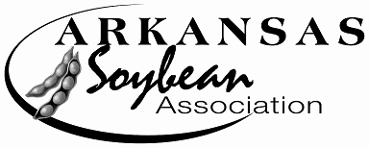
ARKANSAS SOYBEAN ASSOCIATION

1501 N Pierce, Suite 100
Little Rock, Arkansas 72207
501.666.1418 (office)
501.666.2510 (fax)
swsoy@aristotle.net (email)

2022 Yield Contest Harvest Report

Name of grower __________________________________________________________________________________
Farm name ______________________________________________________________________________________
Address __________________________________________________________________________________________
City/State/zip _____________________________________________________________________________________
Phone Number __________________________ County field is in__________________________________________
**EMAIL ADDRESS__________________________________________ T-shirt size _______________________
Fax Number __________________________________ Cell Number ________________________________________
Location/Description of Contest Field _________________________________________________________________ ________________________________________________________________________________________________
Variety planted __________________Conventional________ Roundup Ready______
Liberty Link _________ Dicamba___________
Date planted ___________________________
**DIVISION__________________________________________

Harvest information: (Please attach copies of all weigh tickets showing Weights, Moisture, and Foreign Matter)

Harvest date ______________________________________________________________________________________
Harvest Moisture ________________________________________________________________________________
Foreign Matter *___________________________________________________________________________________
*INDICATE FOREIGN MATTER EVEN IF IT IS LESS THAN 1%

Field must be harvested before December 1, 2022 and Report postmarked on or before December 1, 2021. Primary ACO will acquire a probed one (1) pound sample (in bag provided) and send to the office.

PLEASE COMPLETE ALL FORMS
(PRODUCTION DATA SHEET (online), HARVEST REPORT AND
HARVEST WORK SHEET- on back). THANK YOU.
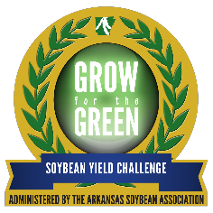
2022 Yield Contest Work Sheet
All calculations should be rounded off at the third decimal place.

Net Weight:

_______________÷ 60 = ______________________ (A)
Pounds Bushels

100 - _____________÷ 87 = _____________________ (B)
Moisture 0.0% Factor

Certified Area:

_______________ X ______________________ ÷ 43560 = _________________ (C)
Length in feet Width in feet Acres

_______________ X _______________ ÷ ____________________ = _____________________Bu/A (D)
(A) (B) (C)

_______________ X ___________ = __________________ Bu/A (E)
(D) (FM ÷ 100)

______________ - __________________ = ________________Bu/A (F)**
(D) (E)

**Indicates the Final Yield from the contest area of the field adjusted to 13% moisture and for all foreign matter.

TO THE BEST OF MY KNOWLEDGE, I CERTIFY THE ACCURACY OF THIS REPORT:

_______________________________ ___________________________
Signature of Grower Date

________________________________ ________________ ____________________________
Signature of Primary ACO Date CCA License Number or Extension Title

_______________________________ ________________ ____________________________
Signature of Judge 2 Date CCA License Number or Extension Title

Field must be harvested before December 1, 2021, and report postmarked on or before December 1, 2022

Mail form to: Arkansas Soybean Association Email to: swsoy@aristotle.net
1501 N Pierce, Suite 100
Little Rock AR 72207
PHONE: 501-666-1418 FAX 501-666-2510

