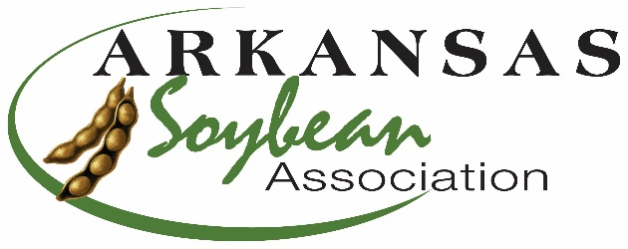
ARKANSAS SOYBEAN ASSOCIATION

1501 N Pierce, Suite 100
Little Rock, Arkansas 72207
501.666.1418 (office)
501.666.2510 (fax)
swsoy@aristotle.net (email)
www.arkansassoybean.com

FOR IMMEDIATE RELEASE – July 3, 2019
GROW FOR THE GREEN SOYBEAN YIELD CONTEST – entry Deadline August 1, 2019
Little Rock (July 3, 2019) – The Arkansas Soybean Association is pleased to announce the continuation of the Grow for the Green Soybean Yield Challenge. This is the 9th year for the contest and it is open to all soybean producers in Arkansas and the entry deadline is August 1.
The 2019 format continues with the geographic regions and prizes. The state is divided into seven (7) geographic regions and an entire state conventional (non-GMO) category. Categories are:
1. Northeast Delta: Mississippi, Crittenden, and East of Crowley’s Ridge in Clay, Greene, Craighead, Poinsett, Cross Counties
2. Northeast: Randolph, Lawrence and West of Crowley’s Ridge in Clay, Greene, Craighead, Poinsett, Cross Counties
3. White River Basin: Independence, Jackson, Woodruff, White, Monroe Counties
4. Central & Grand Prairie: Pulaski, Lonoke, Prairie, Arkansas Counties
5. East Central Delta: St. Francis, Lee, Phillips, Desha (Snow Lake Area) Counties
6. Southeast Delta: Jefferson, Lincoln, Drew, Ashley, Chicot, Desha Counties
7. Western: Remainder of the state
8. Conventional Division: Entire State non-GMO production.
Cash prizes for each category will be awarded to the top 3 producers (minimum of 60 bushels/acre) at the Arkansas Soybean Association Annual Meeting in January. First place is worth $7,500, 2nd place is worth $5000, and 3rd place is $2500. In addition, the top producer in the State across all categories will receive additional prize money and a trip to Commodity Classic in March 2020.
New this year is a bonus for producers achieving 120 bu/ac by 2020. The prize for this portion of the contest is $10,000 (split if more than one producer reaches goal).
Crop production information is being compiled by personnel with the Arkansas Soybean Association and/or the University of Arkansas System Division of Agriculture as a resource for Arkansas producers on all those who enter the contests. 2018 data along with all previous contest results are available on the Arkansas Soybean Association website at www.arkansassoybean.com. Extension Agronomist for Soybeans, Jeremy Ross says, “these contests and the production information gleaned from the producers show the continued potential of soybean production in Arkansas. All producers should be interested in the results.” The 2018 crop year produced 1 new 100-bushel winner: William Palsa from Tillar achieved this goal with Local Seed LS4565 and a yield of 107.394 bu/a. A total of 18 producers have achieved the 100 bu/ac. threshold. New producers in 2019 that achieve the 100-bushel mark are eligible for $5000 (divided if more than one) and membership in the club. New 100 Bushel club members are also eligible for a trip to Commodity Classic.
This contest is administered by the Arkansas Soybean Association with funding provided by the Arkansas Soybean Promotion Board using soybean checkoff funds. Crop management assistance is provided by the University of Arkansas System Division of Agriculture Extension Personnel and many of our state certified crop consultants.
A contest field must have been planted to soybean in at least one of the last three production years prior to 2019, and the contestant must have paid the appropriate checkoff assessments on the soybean. Rules for 2019 include the one division/one person or entity/one field. Producers are also requested to notify their County Extension Agent and the AR Soybean Association of specific field location (GPS coordinates) at least 7 days prior to harvest. Field GPS coordinates will also be needed before harvest
Entry forms with a complete list of rules are available by contacting the office at 501-666-1418 or from your local County Extension Agent. They can also be downloaded at www.arkansassoybean.com or www.themiraclebean.com.
###

