FOR IMMEDIATE RELEASE

2025 Grow for the Green Winners Announced

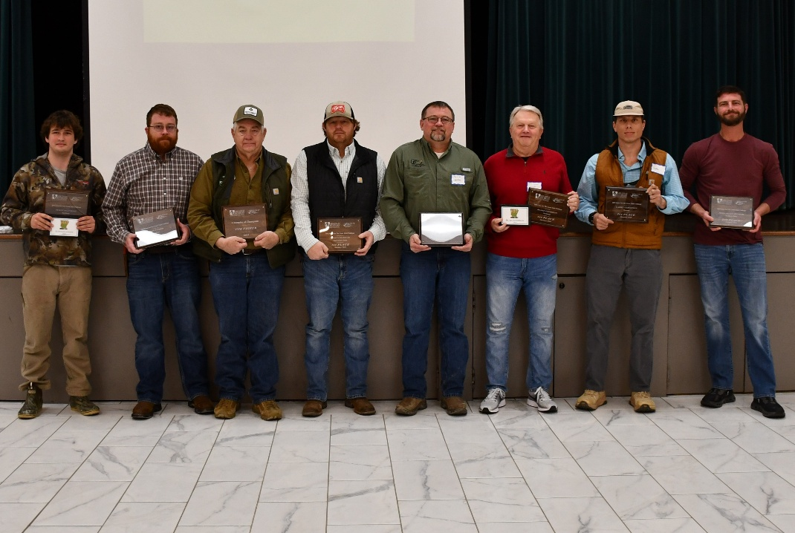

The Arkansas Soybean Association announced the Grow for the Green winners at its annual meeting. Pictured (L to R): Scott Flannigan, Craighead, Northeast, Third Place; Adam Fisher, Cross County, Northeast, Second place; Tim Fisher, Cross County, Champions Group, First place; Brian Chastain, Phillips County, East Central Delta, First Place; Kevin Goble, Mississippi County, Northeast Delta, First Place; Blake Goodman, Clay County, Northeast, First Place; Larry Ferguson, Clark County, Western, First Place; John Allen McGraw, Lincoln County, Southeast Delta, Second Place.

BRINKLEY, Ark., February 10, 2026 – The 2025 Grow for the Green Soybean Yield Challenge winners were announced at the Arkansas Soybean Association (ASA)’s annual meeting on Monday, February 9 in Brinkley. Eight soybean farmers from across the state were honored as the top performers in their respective regions, in addition to two new producers reaching 100 bushels. Administered in partnership with the Arkansas Soybean Promotion Board (ASPB) and the University of Arkansas Extension Services (UAEX), the annual contest strengthens Arkansas’ standing as a leading national producer.
In 2025, soybeans were the second most grown row crop in Arkansas, generating $2.3 billion in cash farm receipts. Arkansas producers harvested on average 55 bushels per acre despite multiple challenges, including flooding and unseasonably warm weather.
“Soybeans continue to be one of Arkansas’ most vital row crops,” said Brad Doyle, Chairman of the Arkansas Soybean Promotion Board and Poinsett County farmer. “That is due to the hard work and determination of soybean producers in this state. Grow for the Green gives us the opportunity to recognize and celebrate the best in the industry.”
Grow for the Green not only rewards the highest-yielding farmers but also encourages the use of innovative farming practices and gathers crucial data that drives continuous improvement in soybean production. The contest remains a powerful platform for recognizing the dedication and expertise of Arkansas’ soybean farmers, who are essential to advancing the state’s agricultural leadership. For each division, first place is awarded $7,500, second place $5,000 and third place $2,500. The Champion Division competes for one prize of $5,000.
This year’s contest showcased exceptional results, with winners from seven regions, one all-state conventional (non-GMO) and a champions category, each honored for their remarkable yields and commitment to sustainable farming practices.
Regional Winners:
- Northeast Delta: Kevin Goble (Mississippi County) – 93.607 bu/ac
- Northeast: Blake Goodman (Clay County) – 102.366 bu/ac
- White River Basin: Bill Rushing (Woodruff County) – 88.999 bu/ac
- Central & Grand Prairie: Tony Richards (Prairie County) – 78.702 bu/ac
- East Central Delta: Brian Chastain (Phillips County) – 92.853 bu/ac
- Southeast Delta: William Lane (Chicot County) – 87.979 bu/ac
- Western: Larry Ferguson (Clark County) – 89.175 bu/ac
100 Bushel Club First-Time Achievers:
- Blake Goodman (Clay County) – 102.366 bu/ac
- Adam Fisher (Cross County) – 101.743 bu/ac
- Scott Flanigan (Craighead County) – 101.683 bu/ac
Conventional Division (Non-GMO):
- John Stephens (Cross County) – 71.017 bu/ac
Champions Group
- Tim Fisher (Cross County) – 104.431 bu/ac
“Hardship isn’t new to Arkansas producers,” said Derek Helms, ASA President and Clark County farmer. “Grow for the Green honors their dedication while highlighting the continued impact soybeans have on the state’s economy. Even in challenging times, the crop remains an agricultural powerhouse.”
To learn more about the Grow for the Green yield challenge, visit TheMiracleBean.com and ArkansasSoybean.com.

###

About Arkansas Soybean Promotion Board
The Arkansas Soybean Promotion Board is led by nine volunteer farmer-leaders appointed by the Governor. Soybeans are Arkansas's top row crop with approximately 3 million acres planted each year, generating an annual economic impact of $2 billion. Arkansas is consistently ranked among the top ten soybean producing states nationally, exporting 50% of its crop. ASPB invests more than $2.2 million in research each year as part of its commitment to the continued sustainability of the Arkansas soybean industry. Learn more by visiting TheMiracleBean.com.

About Arkansas Soybean Association
Since 1964, the Arkansas Soybean Association has worked diligently to enhance the economic viability and social well-being of Arkansas soybean producers and their industry. The ASA is an affiliate of the American Soybean Association and is governed by a board of 30 volunteer farmer-leaders from across the state. Learn more about the Arkansas Soybean Association at www.arkansassoybean.com.

